***//*Cokputer Science Project**

***(topic) CAR PARKING RESERVATION SYSTEM (/topic)  
 Session=("2016-2017")*  
  
  
*Saif Khan***

*** Made On: Python 3.4***

*CERTIFICATE*

*This is to certify that the COMPUTER SCIENCE project titled* ***"CAR PARKING RESERVATION SYSTEM"*** *has been successfully made and submitted by SAIF KHAN of* ***CLASS XIA*** *under the guidance of MR. RAJU RANJAN(PGT-Computer Science) during the session 2016-2017.*

*Signature*

**ACKNOWLEDGEMENT**

*I express my deep sense of gratitude to my teacher* ***Mr. Raju Ranjan*** *who gave me the great opportunity to further develop my skills by doing this project. Also, I would like to thank* ***my friends*** *for their guidance, supervision and encouragement.  
  
I would also like to thank* ***my parents*** *who guided me through the course of this project. I am immensely obliged to* ***my brother*** *who inspired me with the idea behind my work and helped me shape the present work as it is now.*

*Contents   
  
(1.0) Start Screen  
 (1.1) Placing the photo   
 (1.2) Making buttons below the photo  
 (1.3) Making a button that creates a Toplevel window named FirstScreen*

*(2.0)First Screen   
 (2.1) Making the Toolbar on the top of the window  
 (2.2)Placing image of the city below the toolbar*

*(2.3)Placing three images below the city image   
 (2.4)Making the Entry Form and placing on top of the images   
 (2.4.1) Checking if the user has entered information using Submit Button  
 (2.4.2) Designing a quit button to add option to exit program   
 (2.5) Creating the BackEnd system that checks for available parking spaces*

*(3.0) Receipt Window*

*(1.0) Start Screen  
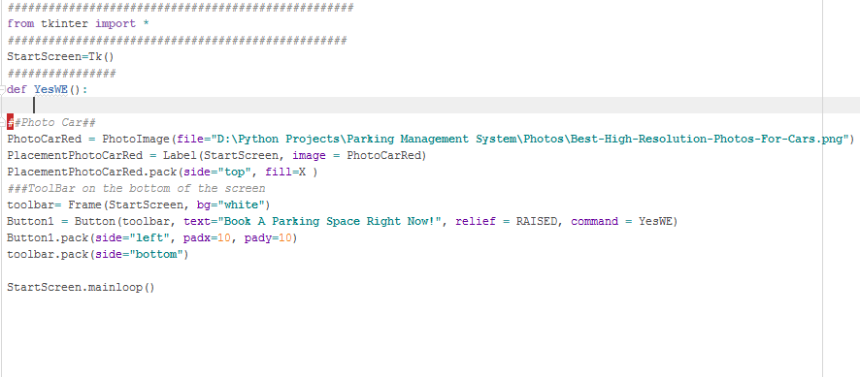(1.1) Placing The Photo   
  
(1.2) Making A Button Below the Photo   
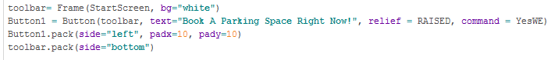  
  
(1.3)Making A Button That Creates a Toplevel() window.  
Code for the button.   
ButtonCode.png*

*It can be seen that the button has been assigned to a function using command. The function will be used to create a toplevel window named FirstScreen. The whole code for the FirstScreen will be placed inside the function YesWE. Therefore, you can view the code on the FirstScreen page.*

*(2.0) First Screen*

*toplevelFirstScreen.png   
(2.1) Making Toolbar on top of the window.   
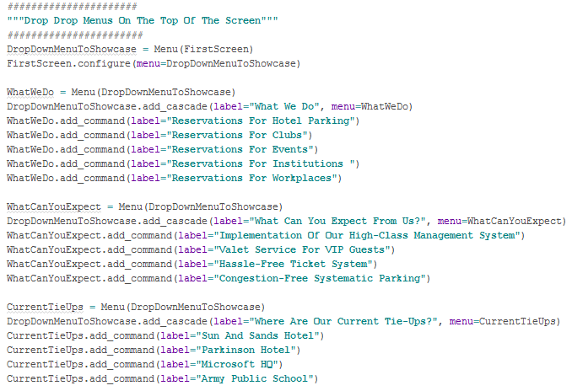  
(2.2) Placing Image Of A City   
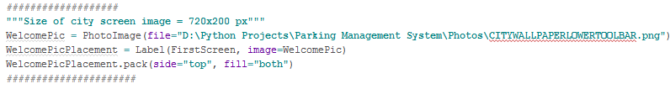  
(2.3) Placing three Images below the city image  
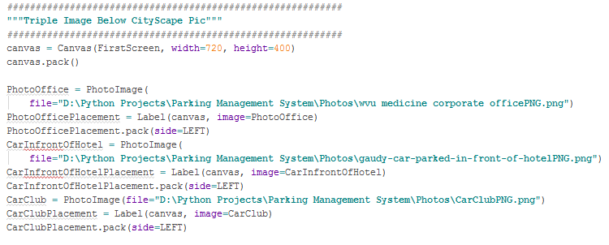(2.4) Making An Entry Form And Placing It On Top Of Images  
(with RadioButtons for Destination and CarType)   
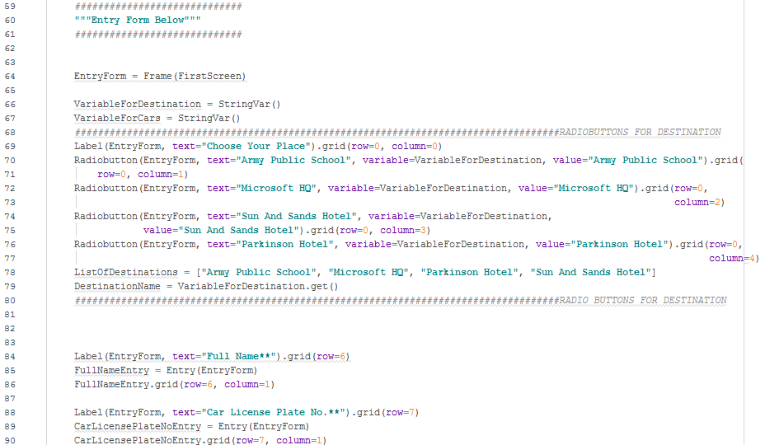  
  
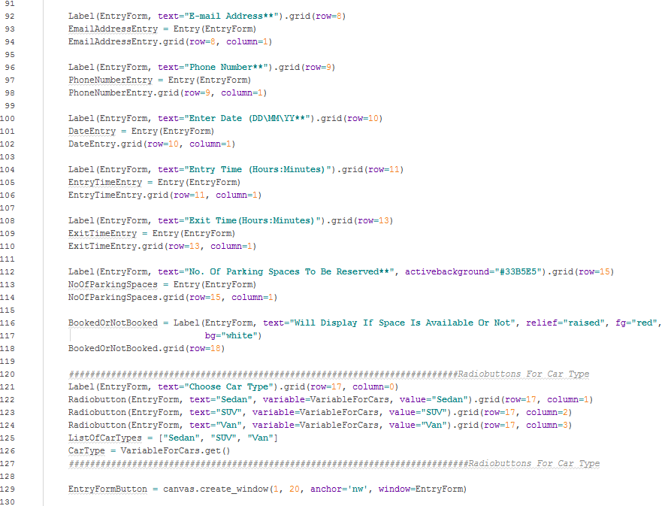  
 (2.4.1) Checking if the user has entered information using Submit Button  
(When you select your destination and car type using the radiobuttons and press the Check Availability button, it will show if the place has parking space available for the car type you have chosen.   
It will update the label BookedOrNotBook (see photo above or line 116 of code) to Yes or No depending on the availability of place)  
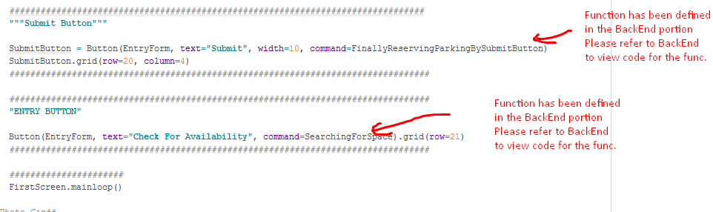  
 (2.4.2) Designing a quit button to add an option to exit the program  
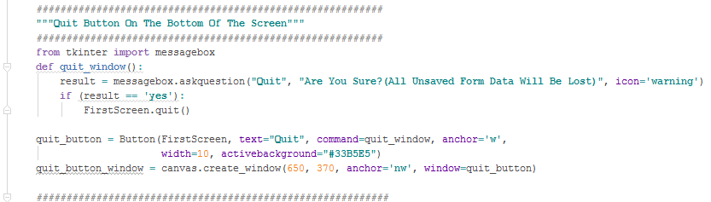*

*(2.5) Creating A BackEnd System that checks for availability of places.   
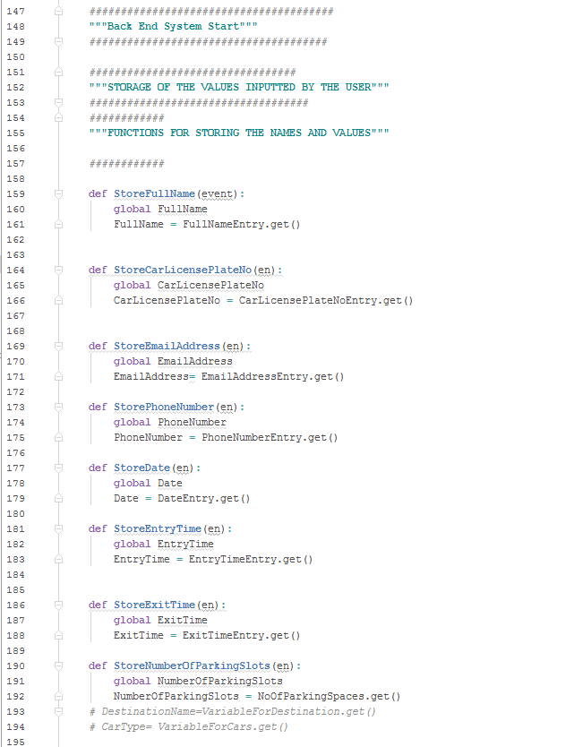*

*(Making Indexes For The Parking Slots )  
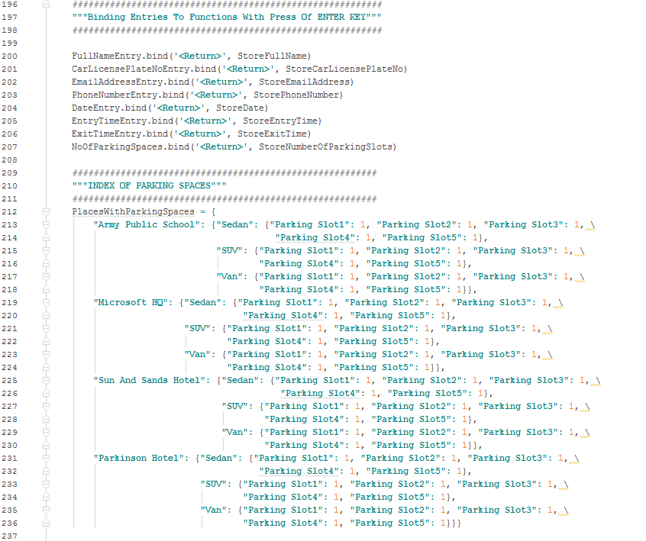  
  
  
  
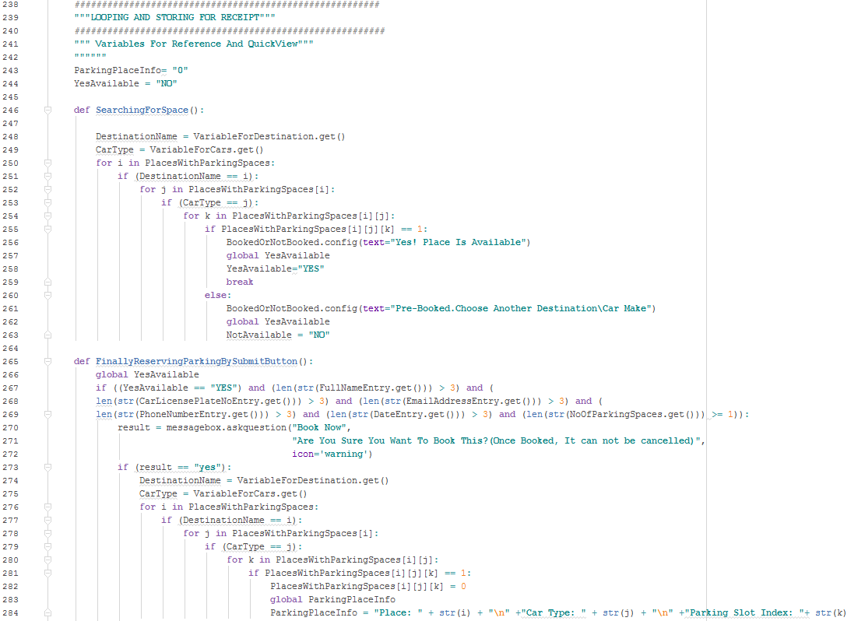  
^^These loops will check if the place and cartype has a value =1   
The value 1 stands for AVAILABLE   
and 0 stands for NOTAVAILABLE.   
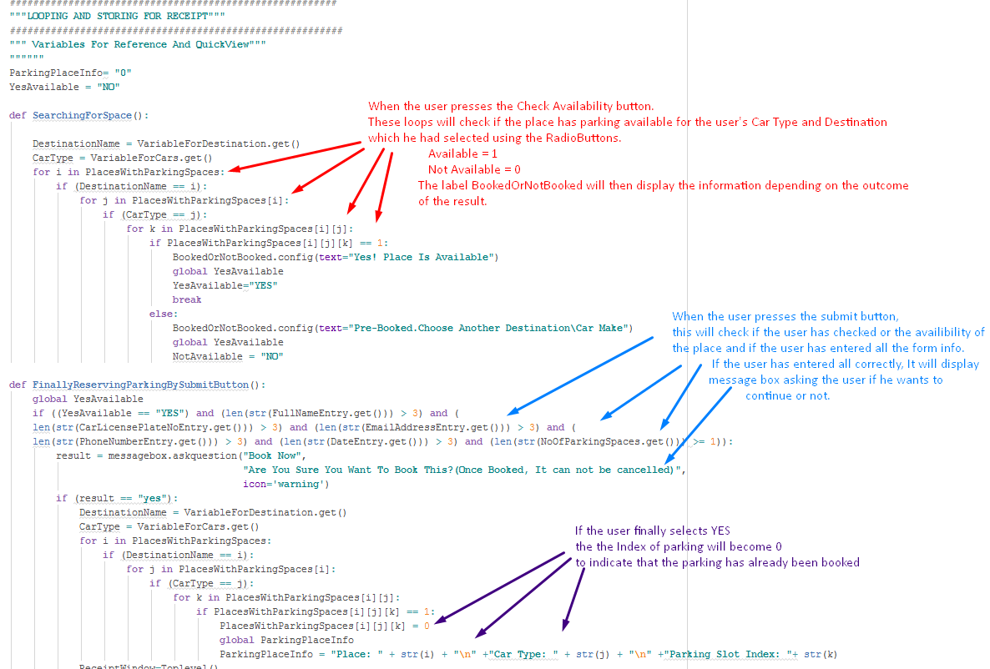*

*(3.0) Receipt Window  
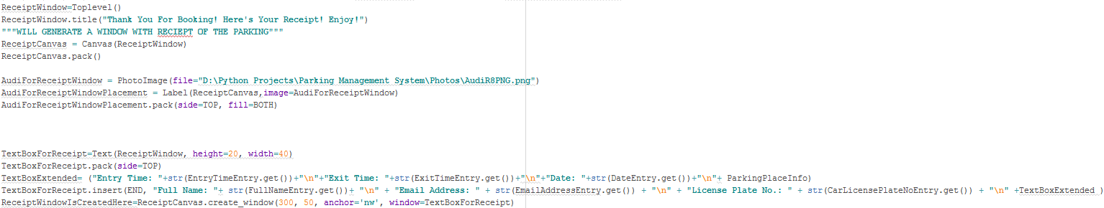  
The code will create a Text Box with all the entries of the user and display it as a receipt.*

*OUTPUT   
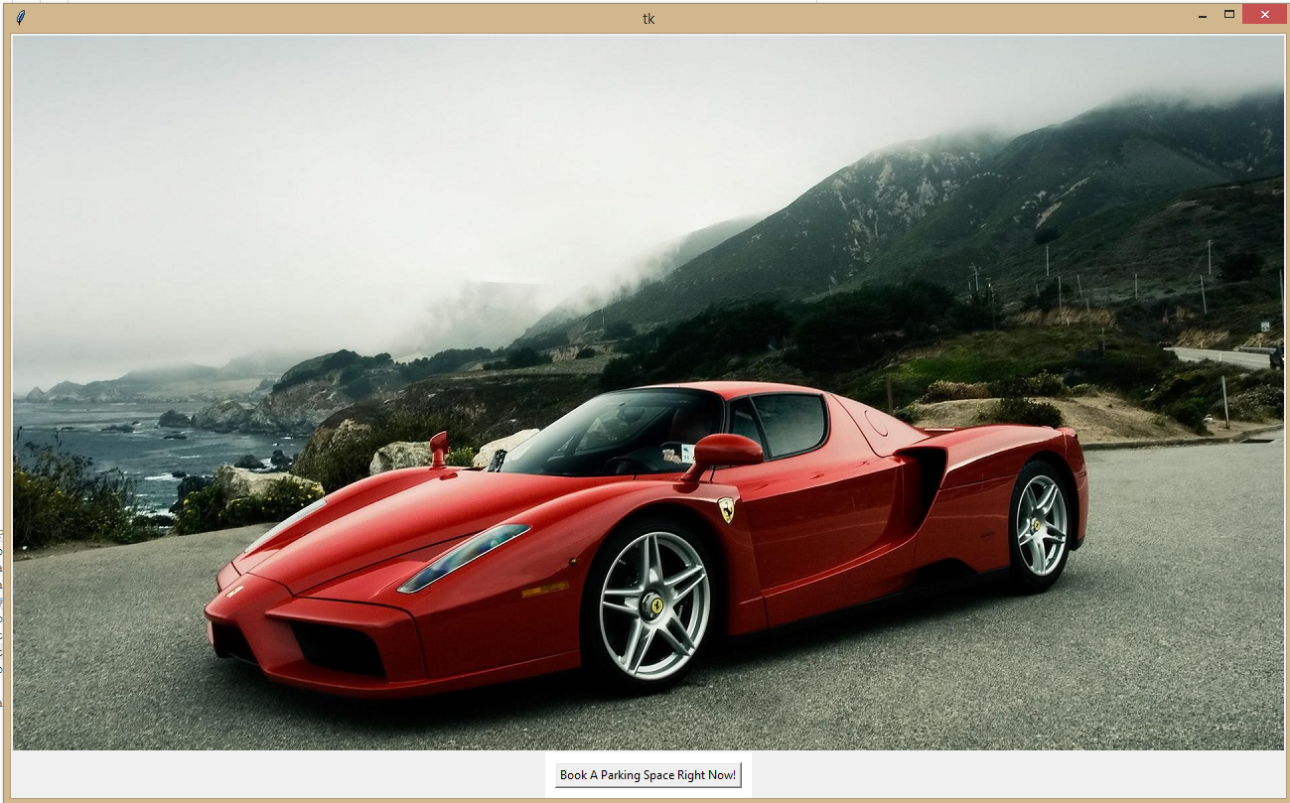*

***Output For FirstScreen And Receipt Window*** 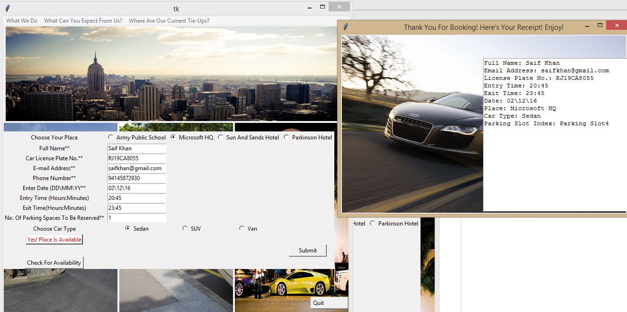

**BIBLIOGRAPHY  
  
*-Python 3.4*** and ***Tkinter*** programming tutorials by  
**Bucky Roberts** on his ***Youtube channel*** *https://www.youtube.com/user/thenewboston*

*-*Immensely helpful numerous pre-existing ***StackOverflow***forum threads*,  
>>http://stackoverflow.com/questions/4522786/modifying-a-global-variable-inside-a-function  
>>http://stackoverflow.com/questions/28822809/how-to-make-a-button-open-a-new-window  
>>http://stackoverflow.com/questions/37238710/how-to-open-a-new-window-by-clicking-a-button-using-tkinter-in-python  
>>http://stackoverflow.com/questions/13295119/opening-a-new-tkinter-window-from-another-window?rq=1  
>>http://stackoverflow.com/questions/11980812/how-do-you-create-a-button-on-a-tkinter-canvas/11981214#11981214  
>>http://stackoverflow.com/questions/41413520/how-do-i-get-buttons-on-top-of-an-image-using-tkinter-python* ***Just to highlight a few of many*** *.*

*-*I made threads on forums online and posted my queries seeking help. Mentioning my threads below-  
*>>http://python-forum.io/Thread-Tkinter-Make-A-Button-That-Opens-Another-Tk-Window-That-I-Have-Made  
http://python-forum.io/Thread-Tkinter-How-do-I-get-buttons-on-top-of-an-image  
>>https://www.daniweb.com/programming/software-development/threads/507049/make-a-button-that-opens-another-tk-that-i-have-made-python-tkinter >>http://stackoverflow.com/questions/41413520/how-do-i-get-buttons-on-top-of-an-image-using-tkinter-python*

- *http://effbot.org/* and its various articles, mentioning a few below-  
*http://effbot.org/tkinterbook/  
http://effbot.org/tkinterbook/canvas.htm  
http://effbot.org/tkinterbook/entry.htm  
http://effbot.org/tkinterbook/text.htm*